HCC 6600: Final Project Checkpoint 3
David Welsh

The current state of Human Feedback:
This continues to be a stumbling block. The fact is that, since I’m writing this from a small town in the Northwest Corner of Lower Michigan, going to any kind of Art Gallery/meetup is off the table. And when it is hypothetically possible, the people present have absolutely no interest in any kind of technology, coincidentally, at 31, I also tend to be about 30~ years below the average age, so talking to them about anything new is borderline off the table. Moreover, attempting to crowdsource from other participants in this graduate program has been almost pointless, as I’ve gotten one response to my google form. However, amongst my friends and people I’ve reached out to, there was a clear eager tone in people’s responses to try this.
Where human feedback has been critical was in developing the model for the project. I’d seen a few examples of AI being used to match people with art pieces, but never something that one could say “I want to see X with Y colors, from Z movement”. But with the relatively sparse nature of metadata on the arts, I was a breath away from just writing out a proof of concept report for this project. A chance response to a cold email sent to the former director of the Art and Artificial Intelligence lab at Rutgers changed that. We met over a zoom call on a Tuesday a few weeks ago, I explained my plans and what I was trying to build, and he gave me the directions to both the necessary tools to build it, and some direction for applications of it.

The current state of the Interface
Perhaps this is just my own development philosophy biting me in the butt, but the interface is currently my next step of development. I generally develop and test the backends of my applications before working on the frontends for them. And this case has been no exception. There’ve been a few quality of life experiments I’ve performed in order to determine what technologies to use for things such as authentication, how to link the web and mobile applications, and to be blunt, the cross platform authentication has been a nightmare… But one I’m since past.
As of writing this, I’ve wireframed the frontend, setting up most of the pages that the data will be propagated to. My goal by the end of day is to have the backend configured, and to begin work on the “taste test, visit plan, and personalizing the feed for the user based on the former.” I’d say there’s about a 65% chance of that happening before midnight, and a 100% chance of it happening before noon tomorrow. For the sake of demonstrating that I am not all talk I’ve included screenshots of what I’ve so far built of the application. My goal is to have the AI model outputting most of the art that you see by day’s end.

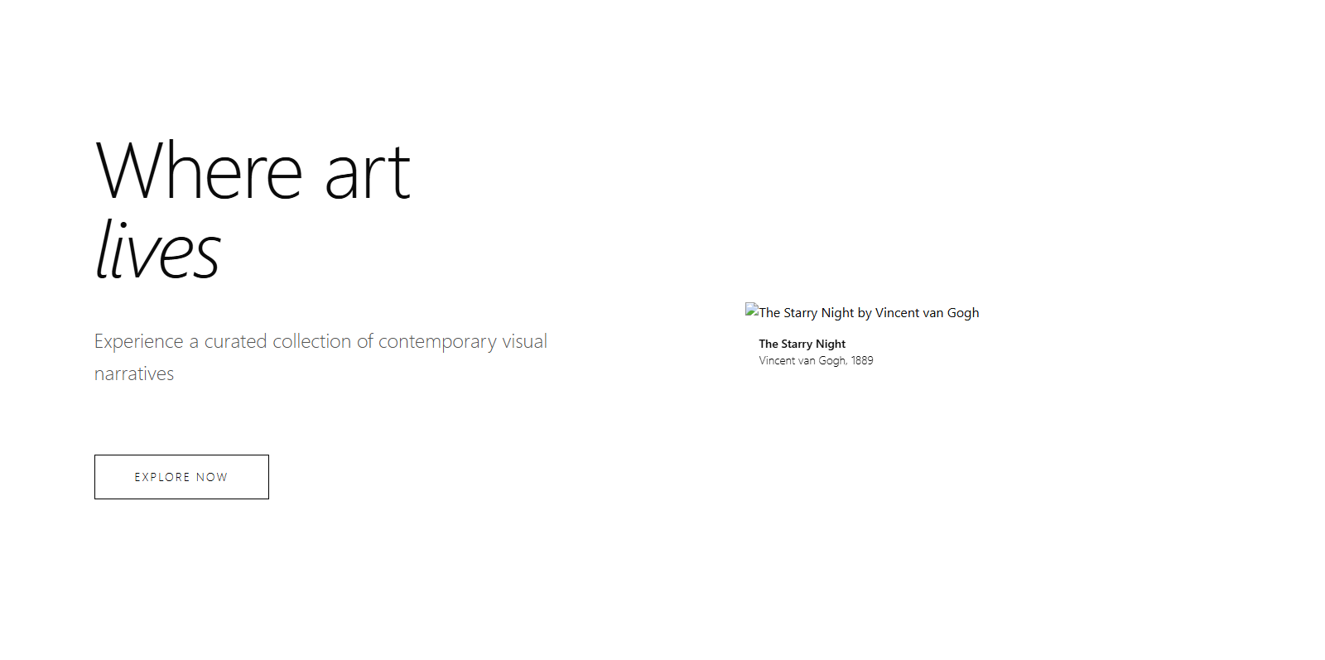
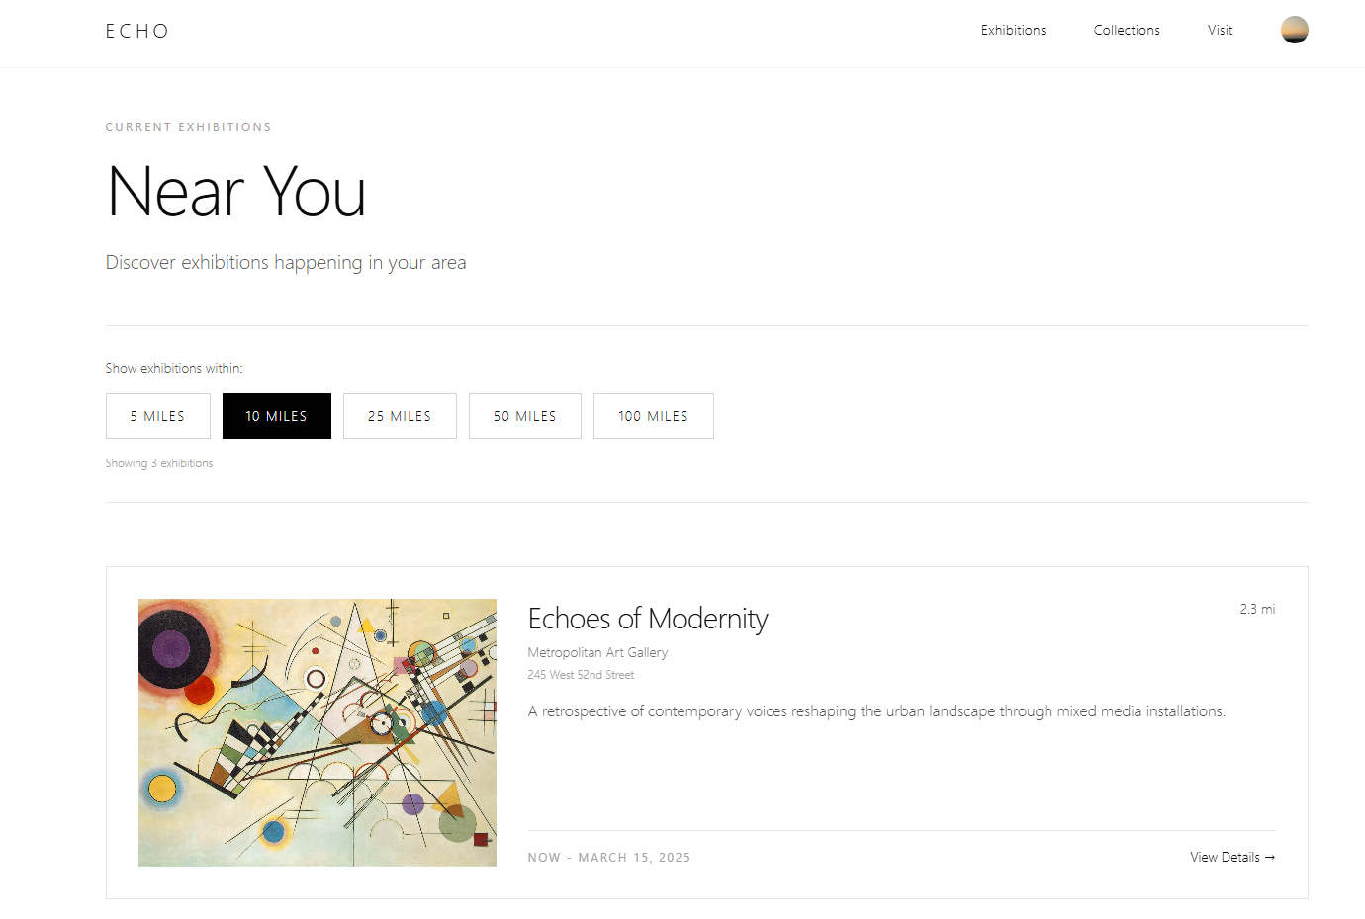
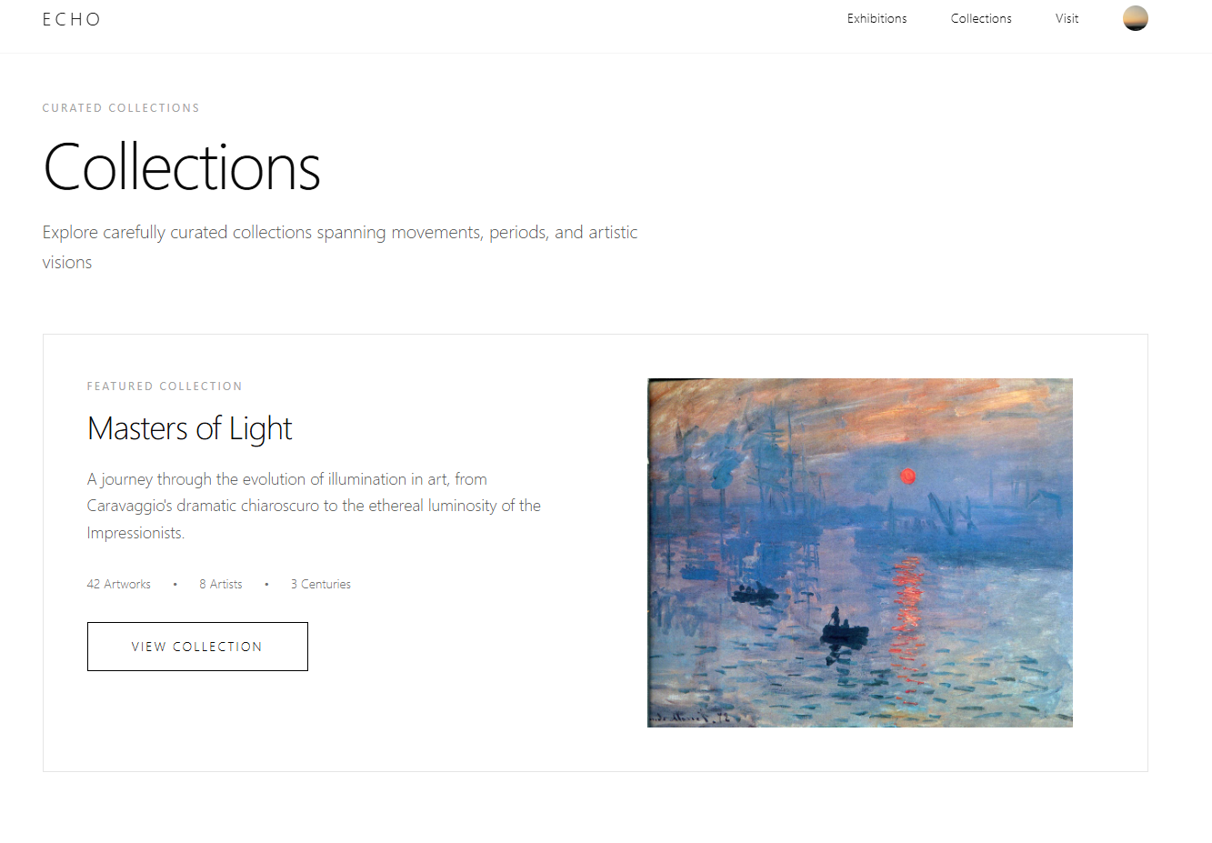
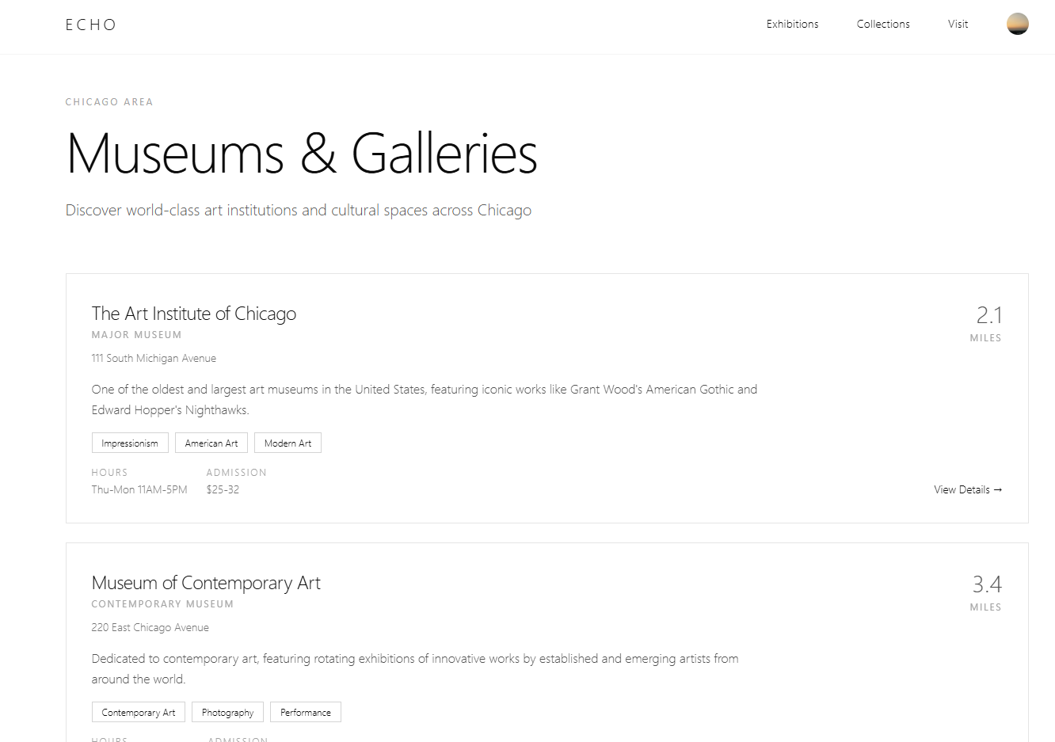

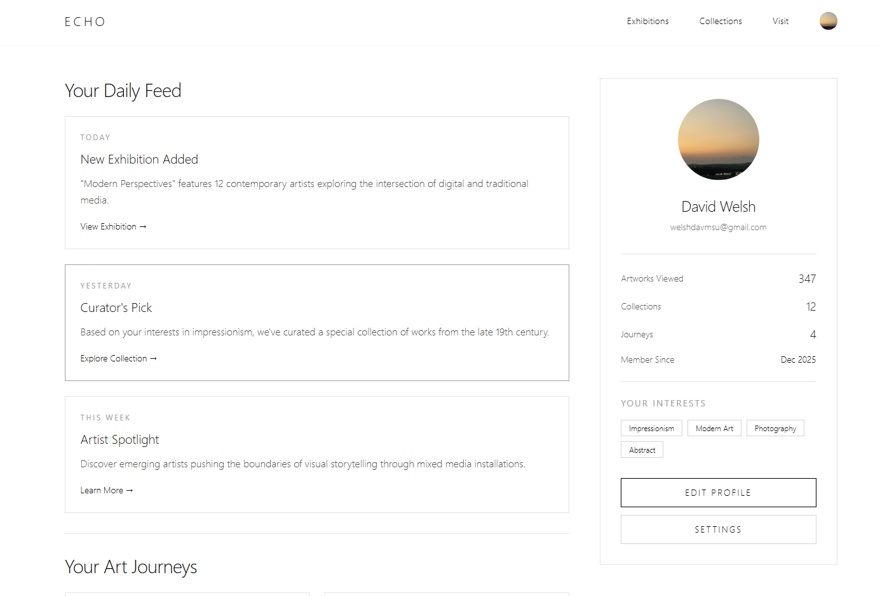
The Evolution of Your AI System
Until around 5:30PM on Monday the 1st, I was skeptical as to whether an AI model would do the things that I needed for this project. I thought something like it was possible after seeing a similar project. In truth, I was very surprised as to how little research there was into the intersection of the Arts and Computer Vision.
Turns out that building a system that could, theoretically be used to explain/recommend art is something with almost no research behind it. Luckily as I previously, I was able to find the Art and Artificial Intelligence lab at Rutgers and get the critical feedback to develop the AI model for this from them.
This is the rough function of the model in action. The prompts were something to the tune of “summer scenes with rich tones of yellow and blue.” And “Picasso at critical points” or something to the tune thereof, to be blunt, I was riding the wave of endorphins from the twin thrills of it both not crashing after taking 2+ hours to train, and from it working better than I’d dreamed it would on the first go. However, and this is very likely a hardware issue, the model’s performance is notably worse locally/in the backend. I’m currently investigating ways that I could mimic deployment/Colab level performance without having to shell out five figures on a new computer…
To summarize, it will take in mood, text, and other forms of sentiment. I’m confident that if I were to scan a photo of a piece in a museum from a mobile app, and ask it to suggest similar pieces, either in the museum or in other places, that it would do so. And for the sake of being able to focus on it, so you can actually take it for a spin yourself, I’m going to keep the rest of this brief so that I can return to work on it.

The Current State of Deployment
If I wanted to deploy it as soon as it is developed, it could be. And in all seriousness, that will ne the case. The plan is to go with my tried and true method of Railway for the backend, Vercel for the frontend. And use Clerk, and a few other recently learned for various features.
What I’m concerned with is the AI model, and how that will function upon deployment. I’m in the process of adding it to the main application right now, specifically configuring the backend so that it connects to the frontend. I don’t think it’s going to be much of an issue if I take my time to configure things properly, but I won’t believe it until I see and test it. Right now, my concern is making certain that when this is deployed, the model runs as expected.

Describe your plan to convert checkpoints into a final report
Thankfully, the semester has reached a point where this is 90% of my focus. I’m in the process of building the application, and even in the potential event that the final report should be written around a proof of concept, I’m very confident in my ability to have this built within a week of the semester’s end. Note, while I really want to get back to coding this app, I feel that fleshing this section out is a very effective use of time.
The most significant changes to this project have been the waves in “is this possible?”. There was a long stretch where I was beginning to wonder if this was a monumental waste of time due to the lack of insight into Art and AI, as well as the factors that classify art as metadata. In many ways, from the perspective of this project as an overarching whole, I’ve started to consider this something of a “proof of concept/research project” and have wondered if it would’ve been more appropriate for the Deep Learning course, rather than Human Centered AI.
To touch on the HCAI principles, and to take note of where it would likely differ from say a project for CPSC 8430, there has been something of a shift in the tone of this project from being algorithmically driven to algorithmically informed/human guided. The early ideas for this project prioritized technical accuracy. As it now stands, especially if I were to go about pitching this to museums of galleries for partnerships, I would classify it as human in the loop/technology being used to amplify the goals/ideals of the humans involved in the process. I would specifically give museum/gallery curators some input over what is focused on for visitors to their exhibits, instead of the algorithm just randomly pointing the persons to a respective piece.
There are five core values HCAI that have left a notable mark on this project.
Human Agency/Autonomy: Where the system will now preserve user control through editable taste profiles, explainable suggestions, and opt-in personalization that allows for a scaffolded approach to art exploration.
Transparency and Explainability: Model rationale is shown through style tags, similarity matrices, and contextual descriptions of why works are grouped together. This gives the users a sense of interpretability and helps us to foster trust.
Inclusiveness and Accessibility: Changes have been made to ensure visually accessible layouts, culturally diverse datasets, and support for users who are unfamiliar with art terminology.
Accountability and Safety: The shift towards human in the loop decision making will help minimize algorithmic overreach and reduces the risk of misclassification/cultural insensitivity.
Meaningful Human Control: Users can override recommendations, explore alternative styles, or flag irrelevant results so that the system bends to their preferences instead of the other way around.
To be blunt, the impact that this will have on the field of HCAI is going to frankly be quite minimal. However it does demonstrate how AI-driven cultural applications can avoid deterministic personalization and instead foster curiosity, agency, and interpretability. By integrating explainable embeddings, user controlled preference modeling, and accessible UI metaphors, the work contributes to the questions of
- How can recommendation systems encourage discovery rather than confinement?
- How can AI support cultural learning without imposing algorithmic biases?
- What does interpretability look like when the subject matters are subjective, artistic and intrinsically emotional?

The Next Steps for the Project
I am going to end up building this out regardless of the stonewalls that I end up running into. From a personal/professional perspective alone, this project is too valuable to not have as a resume piece. I also see the value in this app for institutions like Art Museums, as it could really help with their goals of making their institutions more educational and engaging. And would love to try to get a few on the platform as soon as possible just to test it out as a real-life proof of concept.
There’s also the potential for turning this into a research project. One of the critical limitations of the Coursera based MS program is that we aren’t really able to do any structured research, and considering how much went into building this application, it would almost feel like wasted potential/ Most likely focusing on “Empowering Art Discovery Through Explainable Embeddings”, “Human Centered Curatorial AI”, or “Balancing Serendipity and Personalization in Cultural Recommendation Systems”. And while this is tempting, it’s something that I feel would be better off if I ran past a few faculty members before acting upon.

In conclusion
This paper has honestly ran longer than I wanted it to. But the potential of this project has me fascinated enough to want to push full steam ahead towards building it out, and having it ready as a proof of concept before submitting the final project to you. So, with that said, to keep this conclusion brief, and light the fire I need it to. Even if the first iteration of the app isn’t as good as you’re expecting, have high hopes for this project.

